Day 6 – What is a small business specialist

In today’s lesson I’m going to show you how to find your local OSDBU. Once you find your local OSDBU than you setup a meeting with him/her for an appointment to discuss your business.

In this video we discuss why this step is so crucial to growing your business in the federal arena.

In this tutorial we discuss what to say, write and how to properly setup a meeting.

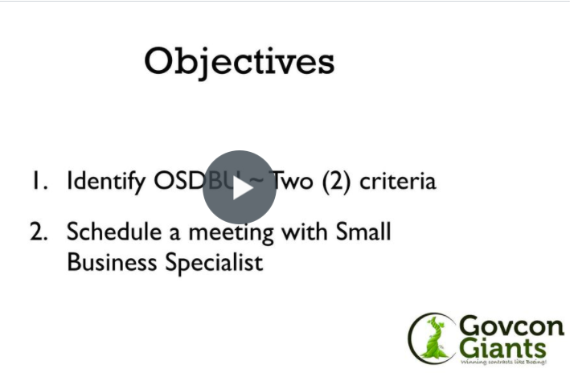

Complete Strategy #2

P.S.: In the lesson you will learn how I landed a multimillion-dollar contract using the very same technique that I am teaching you.

Eric Coffie

